**What we have done last week:**

The algorithm for the single floor: using the name of a place to mark a target.

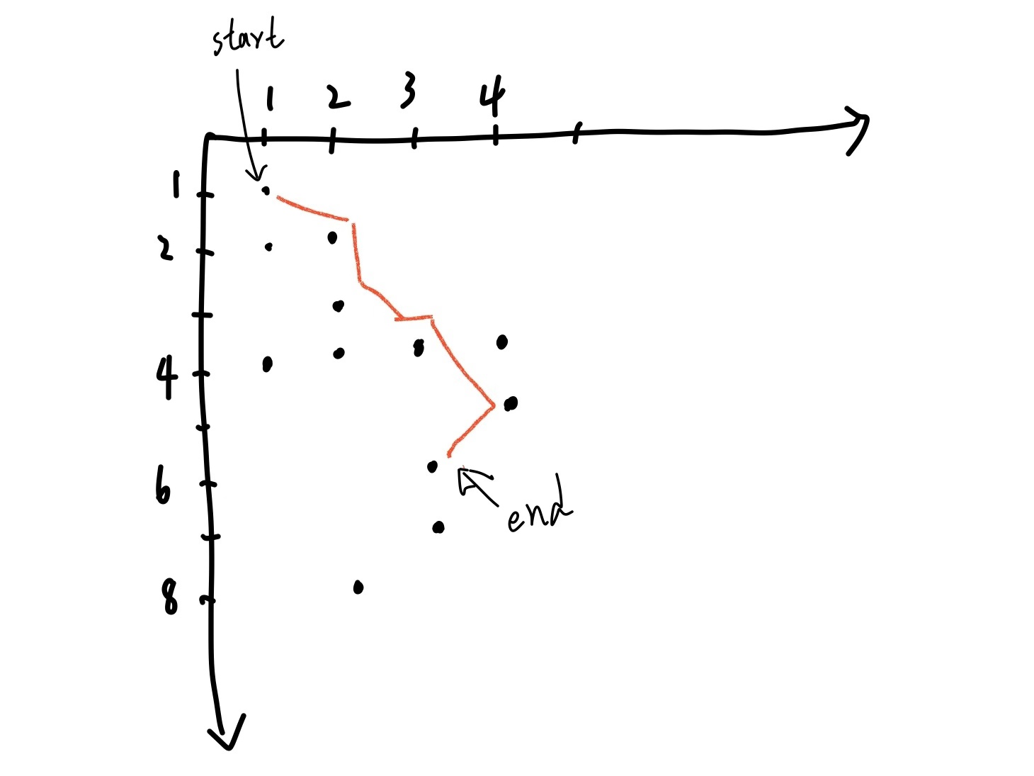

The basic user interface is done, we need to contact our client for confirmation.

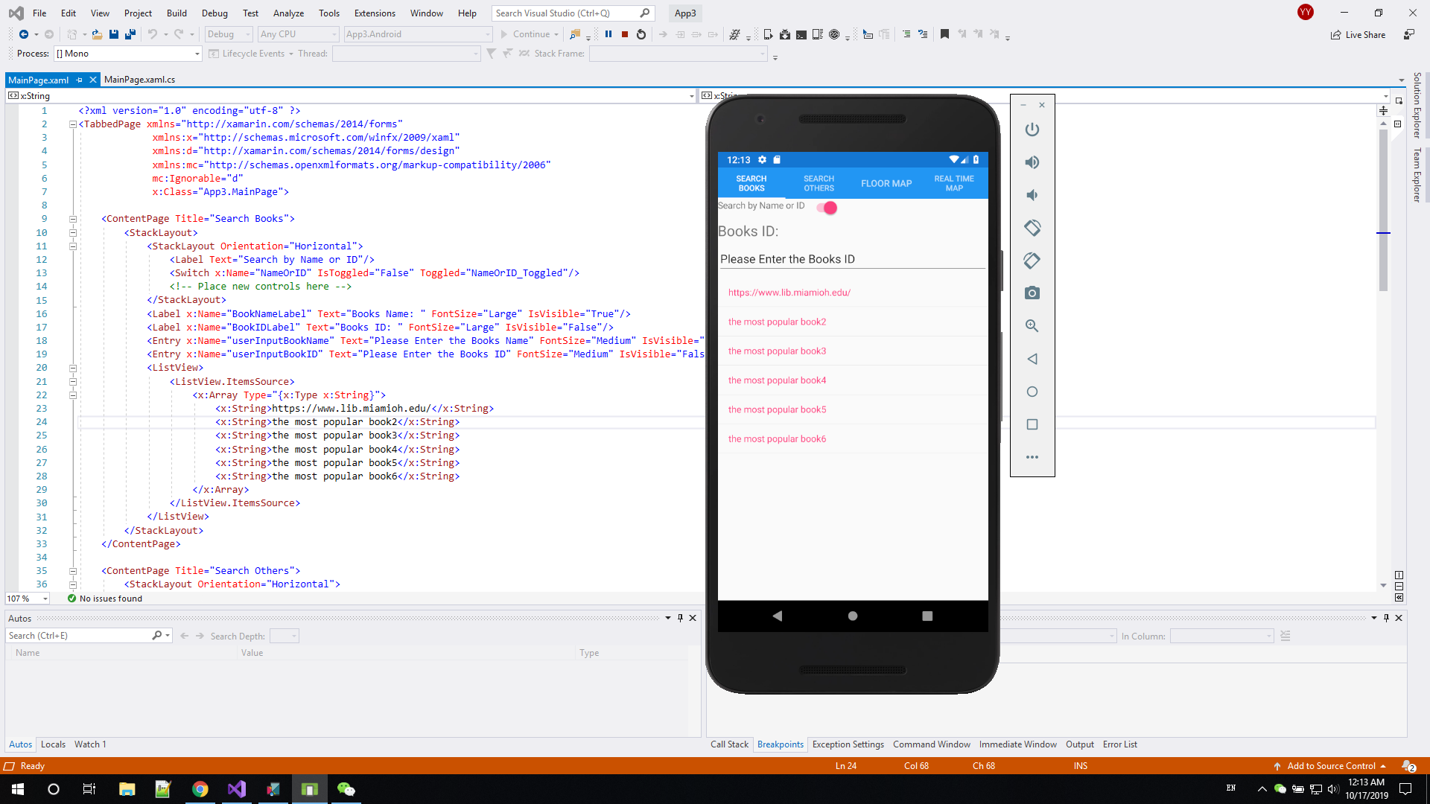

**The progress since the last week:**

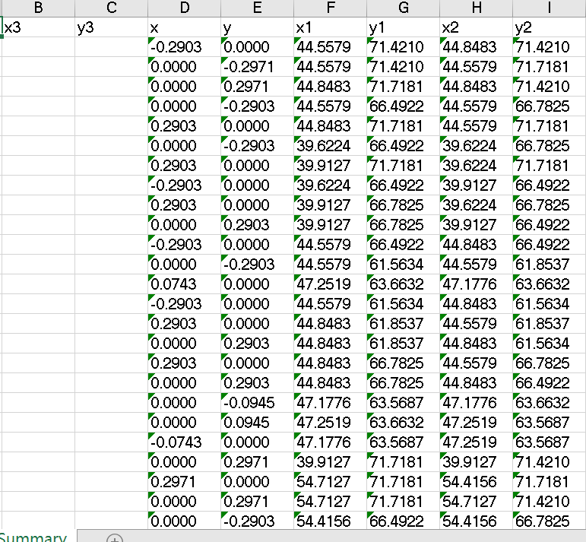

One member (Wenkai) who is responsible for Auto CAD is trying to manually set rooms’ names with associated coordinates after cleaning data (start this weekend).

Since the person (Yangkai) who is learning ArcGIS does not think we are going to use this tool efficiently at this time, so we probably will drop ArcGIS and switch over to the CAD as our main approach to play with map data.

The Algorithm for the single floor is done, and the mapping for the different floor will be finished next week.

Learning SQL lite (a small database could be run on the smartphone).

**What will be done next week:**

Meeting with the client (Mr. Benzing & Miss. Qu) and confirm the UI.

Algorithm for multiple floors.

The first usable (processed) data for the first floor of King Library (*It should be done this week, and will start this weekend*).

**Conclusion:**

We are heading in a good condition with our project, although there are not many tasks done this week.